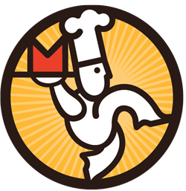**JR. SR.**

**HIGH SCHOOL CAFÉ**

**ALA CARTE SNACKS**

* **Soft Pretzel $1.00** 
  + **With cheese +$0.25**
* **Baked Chips $ Bagged Snacks $1.30**
* **Fresh Fruit $1.00**
* **Fruit Snacks $1.25**
* **Ice Cream *As Priced\***
* **Rice Krispy Treats $1.50**
* **Pudding Parfait Cup $1.50**
* **Fruit Cup $2.25**
* **String Cheese $0.80**
* **Cookies $0.60 or 3 for $1.50**

**ALA CARTE BEVERAGES**

* **Gatorade G2 $2.00**
* **Kickstart $2.50**
* **Milk $0.90**
* **Propel $2.50**
* **Bottled Water $1.25**
* **Snapple/Lipton Tea $2.00**
* **Sparkling Ice $2.50**
* **Yoohoo $2.00**
* **Tropicana Juice $2.00**